5. Graph showing training and test set accuracy after 1, 10, 100 and 1000 training epochs with 10-fold cross validation:

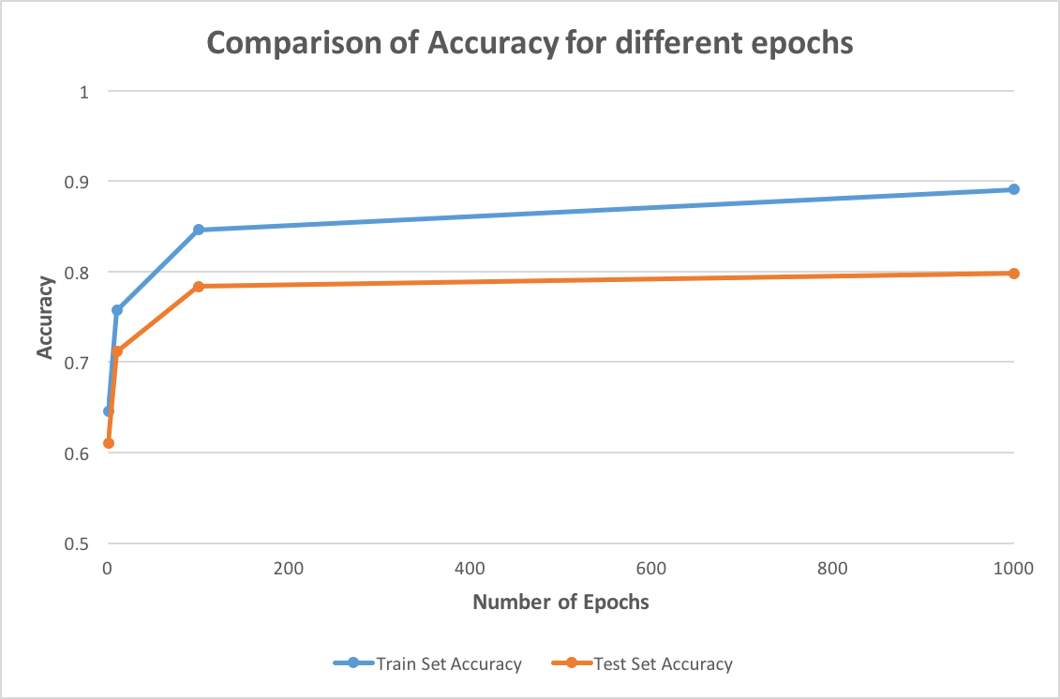

6. ROC curve for a run of stratified 10-fold cross validation with a learning rate of 0.1 and 100 training epochs:

